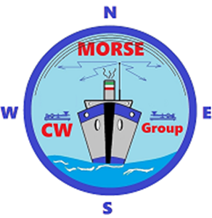

TELEGRAPHIC WEATHER SERVICE

*“Information compiled by the Italian Air Force Meteorological Service and published on the website* [*www.meteoam.it*](http://www.meteoam.it)*”*

**Key:** *Marconi 213 Stright Key*

VVV CQ CQ CQ DE (**CALL**)/MORSE GROUP

METEOMAR TELEGRAPHIC SERVICE ISSUES THE METEOMAR OF THE MEDITERRANEAN SEA

OF 06 OCTOBER 2024 AND VALID UP TO 12:00/UTC OF TODAY.

**KA** (*Start Message*)

**1. WARNINGS**  
THUNDERSTORMS IN PROGRESS: OVER CENTRAL ADRIATIC SEA, SOUTHERN  
ADRIATIC SEA, EASTERN MEDITERRANEAN SEA AND IONIAN SEA.  
EXPECTED THUNDERSTORMS: OVER CENTRAL ADRIATIC SEA, SOUTHERN ADRIATIC  
SEA, EASTERN MEDITERRANEAN SEA AND IONIAN SEA.  
GALES IN PROGRESS: NIL  
EXPECTED GALES: NIL.

**2. WEATHER SITUATION**  
FRONTAL SYSTEM OVER IBERIC PENINSULA IS MOVING EASTERLY. INSTABILITY

AREA OVER AEGEAN SEA IS MOVING EASTERLY. A LOW OF 1010 HPA OVER

WESTERN MEDITERRANEAN SEA IS DEEPENING. QUASI-STATIONARY FRONT OVER

NORTHERN ITALY IS SLOWLY MOVING EAST/NORTHEASTERLY. INSTABILITY AREA

OVER LEVANTINE BASIN.

**3. FORECAST REFERRED TO THE EAST CENTRAL TYRRHENIAN SEA**

-CENTRAL TYRRHENIAN SEA EAST SIDE SOUTHWESTERLY 3 -RAIN COASTWARD

-GOOD LOCALLY MODERATE VISIBILITY -SLIGHT SEA / OUTLOOK:

SOUTHWESTERLY 4 -RAIN COASTWARD.

**AR** (*End Message*)

METEOMAR OF THE MEDITERRANEAN SEA, (*or other sea*) HAS BEEN ISSUED.

DE (CALL)/ MORSE GROUP - AR VA

Signed R.O.

Name operator